CHAPTER 8
EXPECTED OUTCOMES
The Depression Hybrid Neural Network (DepHNN) represents a significant advancement in the field of automated mental health diagnostics using EEG signals. By combining Convolutional Neural Networks (CNN) with Long Short-Term Memory (LSTM) networks, the model is capable of extracting both spatial and temporal features from EEG data. This dual approach enables it to detect local fluctuations across EEG channels and track time-dependent neural patterns that are indicative of depression.
Trained on a validated dataset, DepHNN achieves a classification accuracy of over 99% and a mean absolute error (MAE) of just 0.2040, indicating exceptional precision in distinguishing between depressed and non-depressed subjects. These results affirm the model’s suitability for real-time, non-invasive mental health screening.
One of the model’s key strengths is its computational efficiency. Unlike deeper, resource-heavy neural networks, DepHNN uses a minimal number of convolutional and recurrent layers, making it lightweight and capable of running on standard computing systems. The use of a windowing mechanism during preprocessing segments EEG signals into smaller intervals, reducing computational load while preserving critical information from the time-frequency domain. This results in faster training and inference, making the system ideal for real-world deployment.
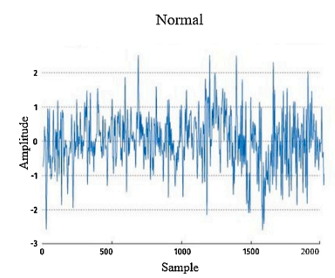
Fig.8.1 Normal EEG Signal
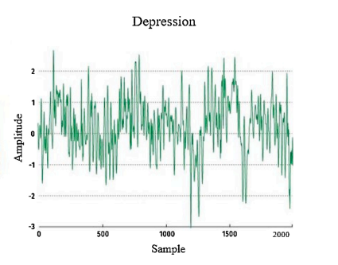
Fig.8.2 Depressed EEG Signal.
Another critical contribution is DepHNN’s ability to eliminate the need for manual feature engineering. Traditional machine learning methods often require handcrafted features based on statistical or spectral analysis, which is labor-intensive and dependent on domain expertise. In contrast, DepHNN autonomously learns features directly from raw EEG data, enhancing both scalability and generalizability across diverse populations and clinical environments.
Due to its low latency, compact design, and high accuracy, DepHNN can be integrated into portable, real-time clinical tools such as wearable EEG headsets or mobile health applications. This makes the model especially valuable in Internet of Medical Things (IoMT) environments, where continuous remote monitoring can be used for early detection and intervention in at-risk individuals.
In addition to its current focus on binary classification, DepHNN’s architecture is extensible. It can be adapted to assess depression severity or repurposed for detecting other neurological and psychiatric conditions like schizophrenia, epilepsy, Parkinson’s disease, or cognitive impairments. This adaptability supports the model’s relevance across a wide range of intelligent healthcare applications.
The successful use of EEG signals in DepHNN reinforces the potential of EEG as a reliable biomarker for depression. EEG is non-invasive, cost-effective, and widely available, making it ideal for deployment in both clinical and underserved settings.
The model’s performance supports its integration into routine diagnostics, especially where mental health professionals or advanced imaging tools are scarce.
From a broader perspective, DepHNN contributes to the field of biomedical signal processing by showcasing how deep learning architectures can be effectively tailored to physiological data. The system is designed to function as a decision-support tool for clinicians, providing objective insights that complement traditional assessments and reduce diagnostic subjectivity.
DepHNN addresses key challenges in EEG-based depression detection and lays the foundation for future AI-driven mental health solutions. With its strong performance, lightweight design, and real-world adaptability, DepHNN holds promise to revolutionize how depression and related disorders are diagnosed, monitored, and managed, making mental healthcare more accessible, personalized, and data-informed.

